# Summary

The following results are summaries of the actual new deaths/cases per day and their predictions using different methods in Iran. The graphs are for the year 2021 and the legends addresses the following items and algorithms:

**Actual values:** The actual new deaths/cases per day.

**Auto SARIMA:** “Seasonal Autoregressive Integrated Moving Average” was used and to optimize the parameters, Auto ARIMA from pmdarima library was used.

**Simple ARIMA:** “Autoregressive Integrated Moving Average” was used and the parameters were extracted from the optimization carried out in a previous file.

**SARIMAX:** “Seasonal Auto Regressive Integrated Moving Average with eXogenus factors” was used with the parameters found in the above “Auto SARIMA”.

**ARIMAX:** “Auto Regressive Integrated Moving Average with eXogenus factors” was used and the parameters were extracted from the optimization carried out in a previous file.

In this part of the study, we used four models and compared the concept, implementation and the performance of the models. The ARIMA model with (p, d, q) parameters, can deliver good estimation of the studied values. Seasonality of the data was observed using seasonal_decompose. The Auto ARIMA using the pmdarima library conducts a search on the parameters. It also takes seasonality input and find the best model. In the SARIMAX model, we have used total_vaccination and stringency_index as exogenous data. And finally, in ARIMAX, seasonality was ignored, and the total_vaccination and stringency_index were used as exogenous data.

The performance of the models was investigated in some sections known as test data. The results do not show improvement of the models using exogenous features in SARIMAX model over SARIMA or ARIMA. Both of the exogenous features have long term effects on the studied values. This implies that the use of total_vaccination and stringency_index as exogenous data requires further investigation on how to use them.

# Deaths

## 60% training:

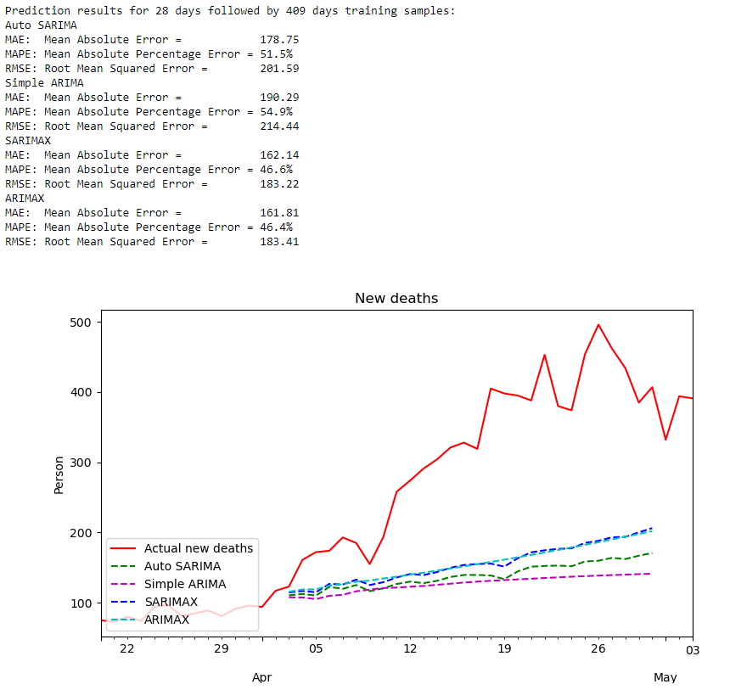

## 70% training:

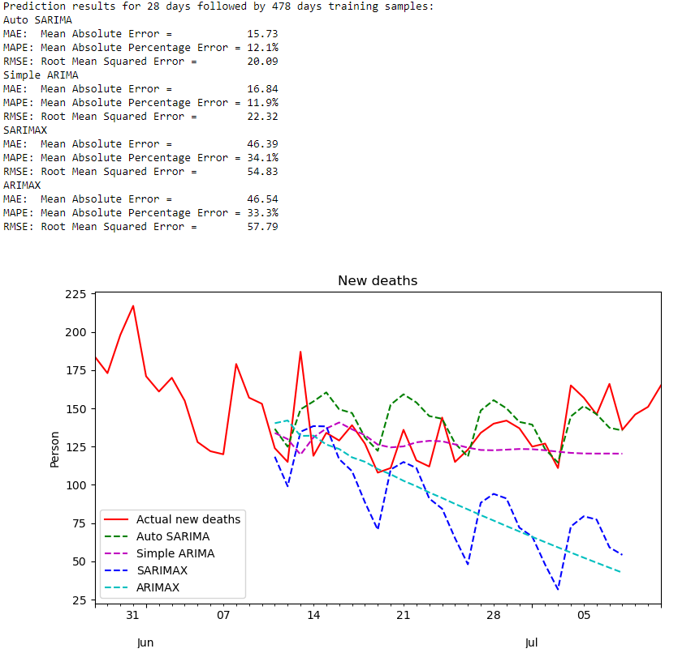

## 80% training:

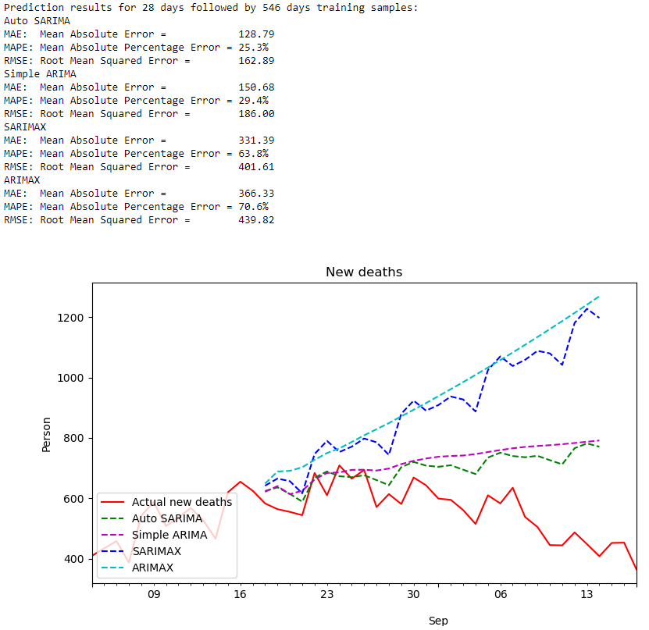

## 90% training:

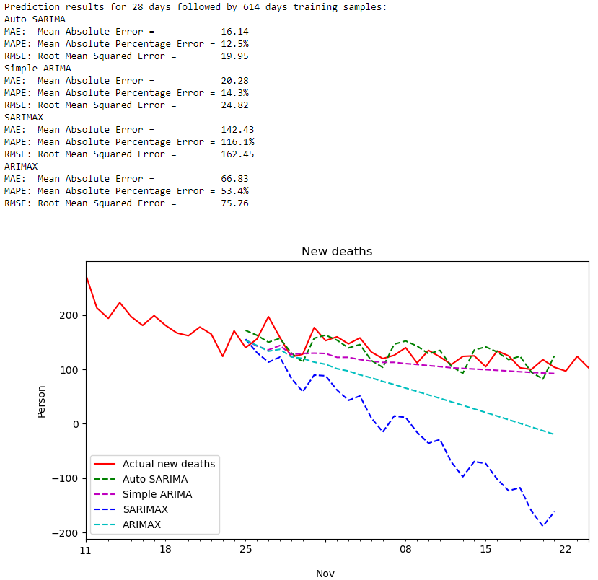

## 95% training:

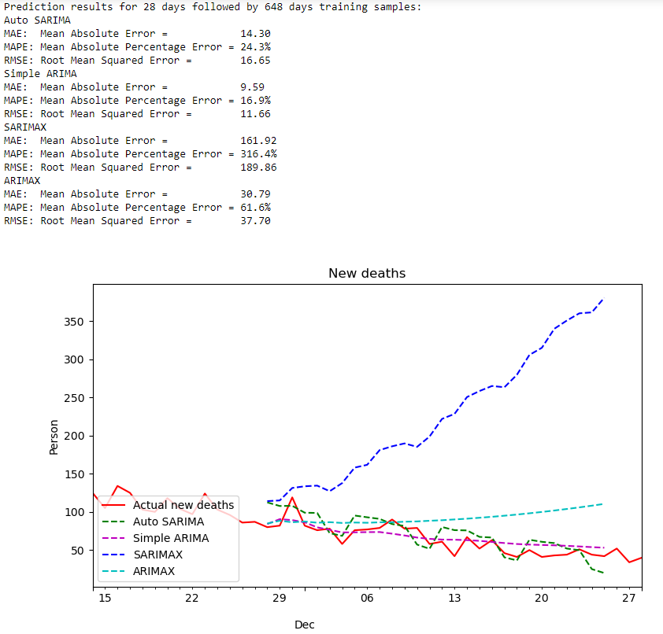

# Cases

## 60% training:

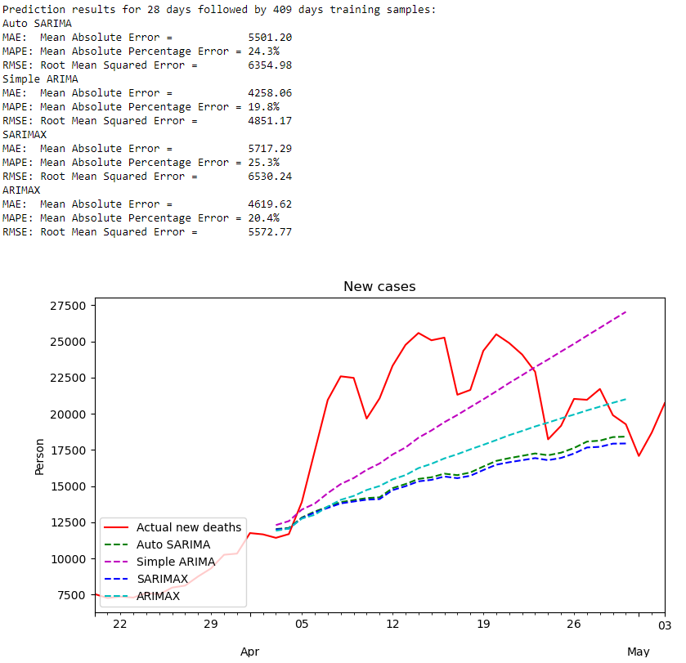

## 70% training:

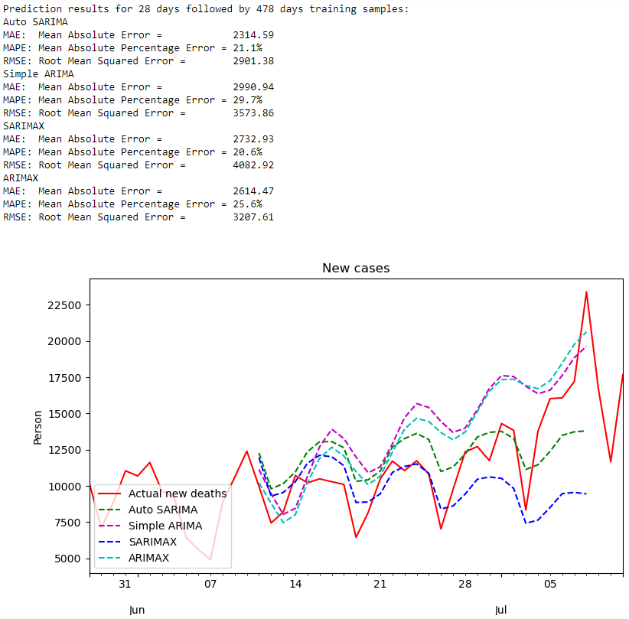

## 80% training:

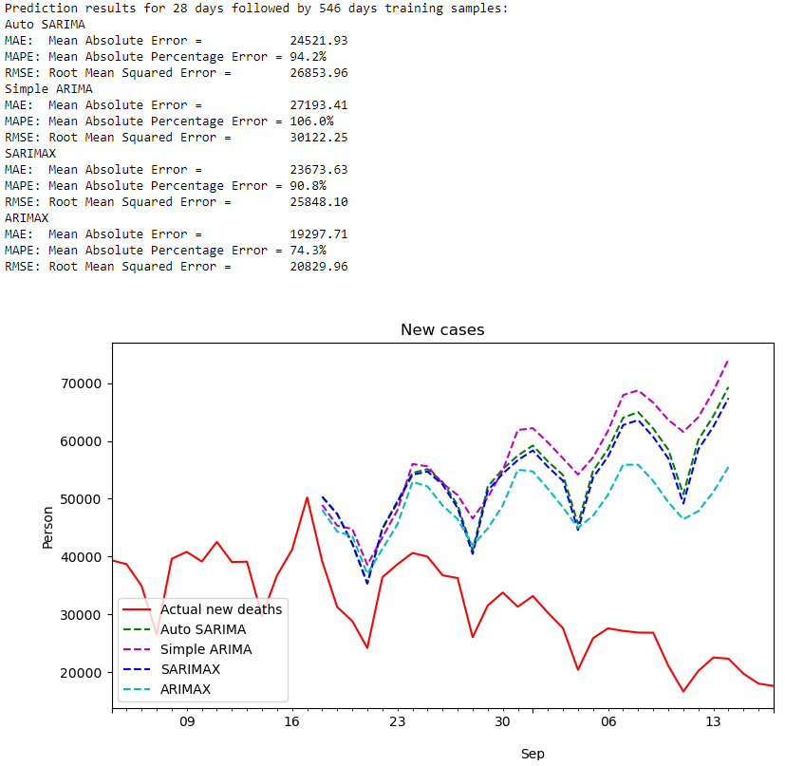

## 90% training:

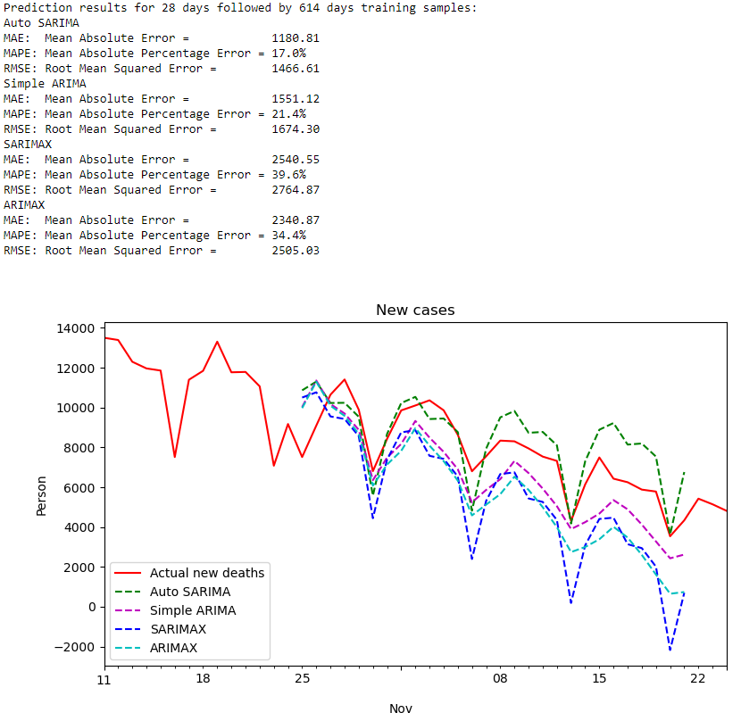

## 95% training:

